UPI IN INDIA: REPORT

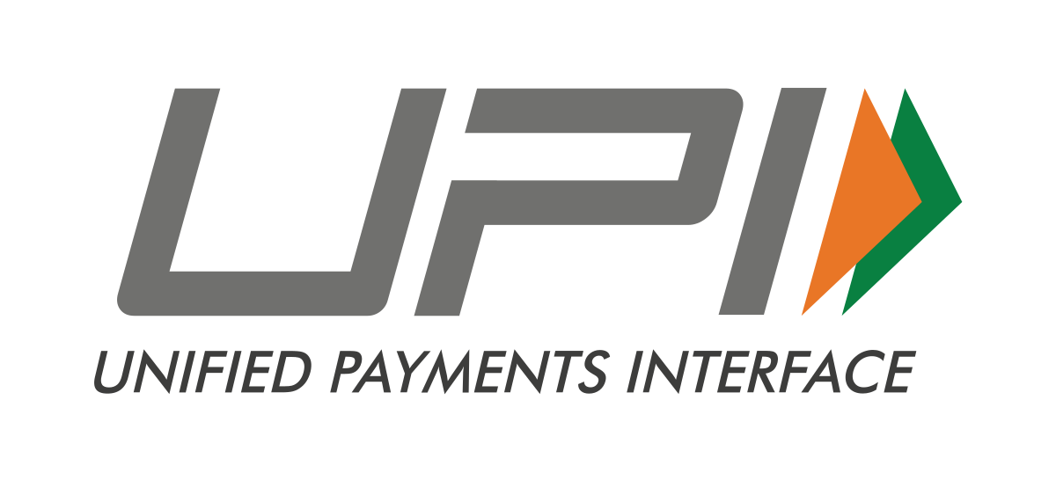

**VIBHORE MATHUR**

**25.10.18**

# INTRODUCTION-

UNIFIED PAYMENT INTERFACE, COMMONLY KNOWN AS UPI, IS A INSTANT AND REAL TIME PAYMENT SYSTEM WHICH WAS INTRODUCED ON 11 APRIL 2016 BY NATIONAL PAYMENTS CORPORATION OF INDIA FOR SAFE INTERBANK TRANSACTIONS. IT WAS AN TYPE OF OPEN SOURCE FACILITY WHICH WAS GIVEN TO MANY E -WALLET APPLICATIONS.

# 

# BEGINNING

UPI IN INDIA WAS INTRODUCE ON 11 APRIL 2016, BUT IT WAS A GRADUAL PROGRESS FOR UPI FROM APRIL-OCTOBER. ON 8 NOVEMBER 2016 PM SHRI NARENDRA MODI ANNOUNCED DEMONETISATION TO KILL CORRUPTION AND, END BLACK MONEY. DENOMINATIONS OF 500 AND 1000 WERE BAN AND NEW NOTE OF 2000 WAS INTRODUCED, BUT IT WAS HARD TO GET CASH DUE TO LACK OF NEW CURRENCY, SO TO OVERCOME THIS PROBLEM E-WALLETS WHICH USED UPI BEGAN TO GET IN TREND GOT POPULAR.

ADVANTAGES OF USING UPI-

CONSIDERABLY USING E- WALLETS AGAINST CASH IS A GREAT METHOD, AS IT IS SAFE, SECURE, AND SIMPLE. ALSO IT EASILY PORTABLE YOU HAVE TO JUST CARRY YOUR PHONE AND YOU CAN BUY ANYTHING ALSO SOME E-WALLETS GIVES YOU EXCITING OFFERS SUCH AS CASHBACK AND SOME DISCOUNTS LIKE 5%,10% AND MORE. ALSO, YOU CAN'T ONLY PURCHASE FROM SHOPS USING E-WALLETS, YOU CAN ALSO PAY YOUR

BILL, RECHARGE YOUR PHONE AND MANY MORE.

DIFFICULTIES OF INCREASING E-WALLETS USE IN INDIA:

SOME DIFFICULTIES ARE AS FOLLOWS

* INDIA HAS LITERACY RATE AROUND 74.04% AND SOME OF THEM EVEN DON’T TO SPEAK SO FORGET ABOUT USING A HIGH CONFIGURATION SMARTPHONE WHICH IS THE ONLY WAY TO ACCESS E-WALLETS.
* ALSO, MANY PEOPLE IN INDIA ARE BELOW POVERTY LINE ABOUT 21.9% PEOPLE IN INDIA EARN BELOW RS.27 PER DAY IN RURAL AND RS 33 FOR URBAN AREA.

GROWTH OF INCREASE IN USAGE OF E-WALLETS IN INDIA:

HERE IS A GRAPH WHICH SHOWS NUMBER OF USERS OF UPI IN INDIA-

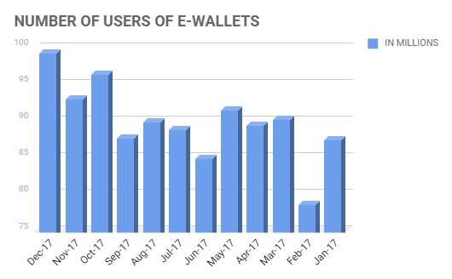

AS THE GRAPH SUGGEST THAT JUST AFTER DEMONETISATION UPI(E-WALLETS) BECOME POPULAR BUT WHEN CASH WAS CIRCULATED IN LARGE QUANTITY USE OF E-WALLETS DECREASED SOMEWHAT.

HOW DOES UPI WORK-

WHEN A USER FIRST STARTS USING E-WALLETS WHICH SUPPORTS UPI,HAS TO DO SOME KYC AND ENTER HIS/HER BANK ACCOUNT OR ADD MONEY TO THE WALLET BY A SIMPLE RECHARGE,THE IF THE PERSON SEND SOME AMOUNT OF MONEY FOR SAY A USER ROHAN WANTS TO SEND RS.2000 TO HIS FRIEND,SAY ROHIT THEN HE HAS TO FIRST CHECK THAT HE HAVE SUFFICIENT BALANCE i.e. Rs.2000 OR MORE IN HIS E-WALLET AND THEN HE HAS TO ENTER ROHIT'S MOBILE NUMBER AND THE JUST HE NEEDS TO TYPE THE AMOUNT i.e. 2000 AND CLICK SENDD IN THE APP THEN THE RS.2000 WOULD BE DECREASED FROM HIS ACCOUNT AND WOULD BE ADDED TO ROHIT'S ACCOUNT. THAT'S SO SIMPLE AND EASY, IS'NT IT?

FREQUENTLY ASKED QUESTION ABOUT UPI-

Q-1) IS USING UPI IS SAFE AND SECURE?

A-1) YES, IN 2018 AFTER CASES OF DATA LEAK BY FACEBOOK AND TWITTER ALL COMPANIES ARE CAREFUL ABOUT THEIR APPLICATION SO IT IS VERY SAFE AND SECURE.

Q-2) IS UPI AVAILABLE FOR ME TO USE?

A-2) YES, UPI WAS OFFICIALLY MADE TO USE BY 9COMMON PEOPLE OF THE NATION ON APRIL 11 2016.

Q-3)What are the charges for using UPI?

A-3) ACCORDING TO THE NATIONAL PAYMENT CORPORATION OF INDIA THERE IS NEGLIGIBLE FEE OF RS. 0.50 PER TRANSACTION.

Q-4)DO I NEED TO REGISTER FOR UPI BEFORE MAKING TRANSACTIONS?

A-4)YES IT IS COMPULSORY TO REGISTER FOR UPI BEFORE MAKING ANY KIND OF TRANSACTIONS.

Q-5) WHICH ALL APP SUPPORTS UPI MECHANISM.

A-5) UPI IS AVAILABLE FOR THE FOLLOWING APPS-

1. PHONE PE
2. Paytm
3. BHIM app
4. MobiKwik
5. Airtel Payments Bank
6. Google Tez
7. Uber
8. Chiller
9. Paytm Payments Bank
10. SBI Pay
11. iMobile
12. Axis Pay
13. BOB UPI